MjH\; Nkdpiyg; gs;sp – nghd;Ndhp
SAT – 02.10.2020
ghlk; - jkpo; kjpg;ngz;fs; - 50
tFg;G – 10 Neuk; fhiy- 5.45 – 6.45
gFjp – 1
m) rhpahd tpiliaj; NjHe;njLj;J vOJf. 10 X1 = 10
1. jkpopdj;ij xd;WgLj;Jk; ,yf;fpakhf k.ngh.rp. fUjpaJ -------------------
m) jpUf;Fws; M) GwehD}W ,) fk;guhkhazk; <) rpyg;gjpfhuk;
2. jd;ehl;L kf;fSf;Fj; je;ijAk; jhAk; kfDkhf ,Ue;j murd; - vd;Dk; nka;f;fPh;j;jpj; njhlH czHj;Jk; nghUs; --------
m) Nkk;gl;l epUthfj;jpwd; ngw;wth; M) kpFe;j nry;tk; cilath;
,) gz;gl;l kdpjNeak; nfhz;lth; <) newpNahL epd;W fhty; fhg;gtH
3. rhpahd mfuthpiriaj; NjHe;njLf;f.
m) coT> kz;> VH> khL M) kz;> khL> VH> coT
,) coT> VH> kz;> khL <) VH> coT> khL> kz;
4. ,Uehl;L murHfSk; Jk;igg; G+itr; #bg; NghhpLtjd; fhuzk; ----
m) ehl;ilf; ifg;gw;Wjy; M) Mepiu ftHjy;
,) typikia epiyehl;ly; <) newpNahL epd;W fhty; fhg;gtH
5. khytd; Fd;wk; Nghdhnyd;d? Ntytd; Fd;wkhtJ vq;fSf;F Ntz;Lk;. – khytd; Fd;wKk; Ntytd; Fd;wKk; Fwpg;git KiwNa----
m) jpUg;gjpAk; jpUj;jzpAk; M) jpUj;jzpAk; jpUg;gjpAk;
,) jpUg;gjpAk; jpUr;nre;J}Uk; <) jpUg;guq;Fd;wKk; godpAk;
6. Nfhg;guNfrhp vd;w gl;lk; nfhz;ltd; -------------
m) Kjyhk; ,uhruhr Nrhod; M) ,uz;lhk; ,uhruhr Nrhod;
,) guhe;jfNrhod; <) FNyhj;Jq;fNrhod;
7. rpyk;Gr;nry;th; vd;W Nghw;wg;gLgtH --------------
m) Kjyhk; ,uhruhr Nrhod; M) ,uz;lhk; ,uhruhr Nrhod;
,) k.ngh.rp. <) t.c.rp.
8. F.g. ,uh[Nfhghyd; gpwe;j Mz;L ---------------
m) 1978 M) 1902 ,) 1987 <) 1920
9. rpyg;gjpfhuk; ----- fhz;lq;fis cilaJ.
m) 2 M) 3 ,) 4 <) 5
10. xsit tpUij – ngw;wtH ------------------
m) rpd;dg;gps;is M) Rg;Gyl;Rkp ,) md;gurp <) tsHkjp
gphpT - 2
midj;J FWtpdhf;fSf;Fk; tpilasp 5 X 2 = 10
11. nka;f;fPHj;jp ghlg;gLtjd; Nehf;fk; ahJ?
12. tWikapYk; gbg;gpd; kPJ ehl;lk; nfhz;ltH k.ngh.rp. vd;gjw;Fr; rhd;W jUf.
13. Gwj;jpizfspy; vjpnujpHj; jpizfis ml;ltizg;gLj;Jf.
14. ghrtH> thrtH> gy;epz tpiyQH> ckzH – rpyg;gjpfhuk; fhl;Lk; ,t;tzpfHfs; ahtH?
15. rpyg;gjpfhuk; vt;thW rpwg;gpf;fg;gLfpwJ?
gphpT – 3
midj;Jr; rpWtpdhf;fSf;Fk; tpilasp 3 X3 = 9
16. jiyiaf; nfhLj;NjDk; jiyefiuf; fhg;Nghk; - ,lk; Rl;bg; nghUs; tpsf;Ff.
17. mte;jp ehl;L kd;dd;> kUjehl;L kd;dDld; NghHGhpe;J me;ehl;ilf; ifg;gw;w epidf;fpd;whd; mg;NghHepfo;itg; Gwg;nghUs; ntz;ghkhiy $Wk; ,yf;fzj;jpd; top tpsf;Ff.
18. Kjy; kio tpOe;jJk; - vd;dnty;yhk; epfo;tjhf F.g.uh. ftpghLfpwhH?
kdg;ghlg; ghliy mbkhwhky; vOJf. 1 X 5 = 5
19. J}Rk; -------- vdj; njhlq;Fk; rpyg;gjpfhug; ghliy vOJf.

gphpT – 4
20. CHg;ngahpd; k&cit vOJf. 4 X 2 = 8
m) cjfkz;lyk; M) irjhg;Ngl;il
21. kaq;fpa - gFgj cWg;gpyf;fzk; jUf.
22. ghliyg; gbj;J tpdhf;fSf;F tpilasp.
gfHtdH jphpjpU efutPjpAk;:
gl;bDk; kaphpDk; gUj;jp E}ypDk;
fl;L Ez;tpid fhUfH ,Uf;ifAk;:
J}Rk; JfpUk; MuKk; mfpYk;
m. ,t;tbfs; ,lk;ngw;w E}y; vJ?
M. fhUfH – nghUs; jUf.
23. fiyr;nrhy; mwpf.
m) Patent M. Territory

fbjk; vOJf. 1 X 8 = 8
24. ehspjo; xd;wpd; nghq;fy; kyhpy; - coTj; njhopYf;F te;jidr; nra;Nthk; - vd;w cq;fs; fl;Liuia ntspapl Ntz;b me;ehspjo; MrphpaUf;Ff; fbjk; vOJf.

MjH\; Nkdpiyg; gs;sp – nghd;Ndhp
SAT – Answer Key – 09.10.2020
ghlk; - jkpo; kjpg;ngz;fs; - 50
tFg;G – 10
gFjp – 1
tpilfs; rhpahf ,Ue;jhy; 1 kjpg;ngz;> gpiofs; ,Ue;jhy; ½ kjpg;ngz; toq;fTk;
m) rhpahd tpiliaj; NjHe;njLj;J vOJf. 10 X1 = 10
1. <) rpyg;gjpfhuk;
2. <) newpNahL epd;W fhty; fhg;gtH
3. ,) coT> VH> kz;> khL
4. ,) typikia epiyehl;ly;
5. m) jpUg;gjpAk; jpUj;jzpAk;
6. M) ,uz;lhk; ,uhruhr Nrhod;
7. ,) k.ngh.rp.
8. M) 1902
9. M) 3
10. m) rpd;dg;gps;is
gphpT – 2
2 gpiofSf;F ½ kjpg;ngz; Fiwf;fTk;.
midj;J FWtpdhf;fSf;Fk; tpilasp 5 X 2 = 10
11. nka;f;fPHj;jp ghlg;gLtjd; Nehf;fk; ahJ?
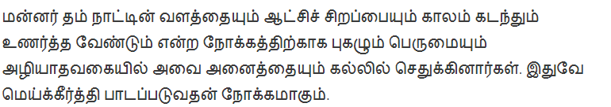
12. tWikapYk; gbg;gpd; kPJ ehl;lk; nfhz;ltH k.ngh.rp. vd;gjw;Fr; rhd;W jUf.
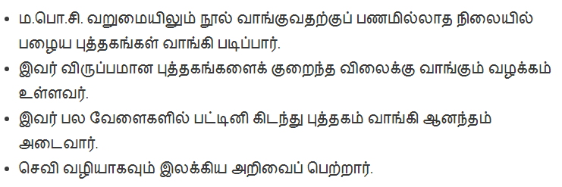
13. Gwj;jpizfspy; vjpnujpHj; jpizfis ml;ltizg;gLj;Jf.
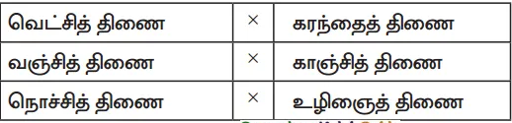
14. ghrtH> thrtH> gy;epz tpiyQH> ckzH – rpyg;gjpfhuk; fhl;Lk; ,t;tzpfHfs; ahtH?
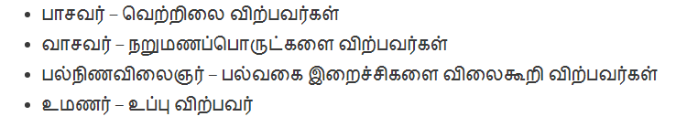
15. rpyg;gjpfhuk; vt;thW rpwg;gpf;fg;gLfpwJ?
Kj;jkpo;f; fhg;gpak;> Fbkf;fs; fhg;gpak;.
gphpT – 3
2 gpiofSf;F ½ kjpg;ngz; Fiwf;fTk;.
midj;Jr; rpWtpdhf;fSf;Fk; tpilasp 3 X3 = 9
16. jiyiaf; nfhLj;NjDk; jiyefiuf; fhg;Nghk; - ,lk; Rl;bg; nghUs; tpsf;Ff.
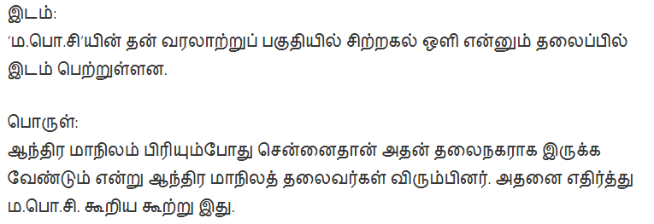
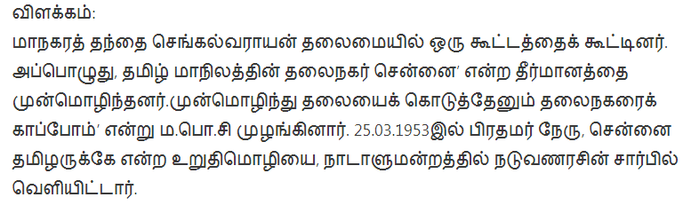
17. mte;jp ehl;L kd;dd;> kUjehl;L kd;dDld; NghHGhpe;J me;ehl;ilf; ifg;gw;w epidf;fpd;whd; mg;NghHepfo;itg; Gwg;nghUs; ntz;ghkhiy $Wk; ,yf;fzj;jpd; top tpsf;Ff.
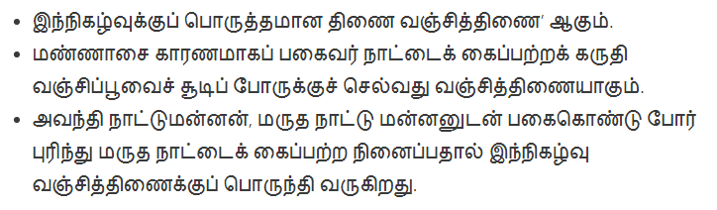
18. Kjy; kio tpOe;jJk; - vd;dnty;yhk; epfo;tjhf F.g.uh. ftpghLfpwhH?
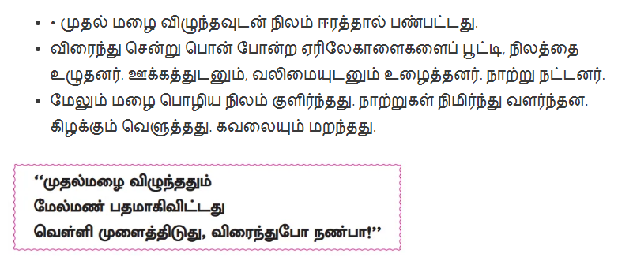
kdg;ghlg; ghliy mbkhwhky; vOJf. 1 X 5 = 5
19. J}Rk; -------- vdj; njhlq;Fk; rpyg;gjpfhug; ghliy vOJf.
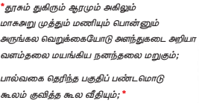

gphpT – 4
20. CHg;ngahpd; k&cit vOJf. 4 X 2 = 8
m) cjif M) irij
21. kaq;fpa - gFgj cWg;gpyf;fzk; jUf.
kaq;F - ,(d;) – a; - m
kaq;F – gFjp
,(d;) - ,we;jfhy ,ilepiy – d; - GzHe;J nfl;lJ.
a; - clk;gLnka;
m – nganur;rtpFjp
22. ghliyg; gbj;J tpdhf;fSf;F tpilasp.
gfHtdH jphpjpU efutPjpAk;:
gl;bDk; kaphpDk; gUj;jp E}ypDk;
fl;L Ez;tpid fhUfH ,Uf;ifAk;:
J}Rk; JfpUk; MuKk; mfpYk;
m. ,t;tbfs; ,lk;ngw;w E}y; vJ? – rpyg;gjpfhuk;
M. fhUfH – nghUs; jUf. nea;gtH (rhypaH) fhg;Ghpik
23. fiyr;nrhy; mwpf.
m) Patent - fhg;Ghpik M. Territory - fhg;Ghpik

fbjk; vOJf. 1 X 8 = 8
24.fbjj;jpy; rhd;wpw;fhf xU ngaUk; tpyhrKk; nfhLf;fg;gl;Ls;sJ. eP cd; ngaiuAk; cd; tpyhrj;ijAk; vOjNtz;Lk;.

